ADVANCED DBMS LAB

EXPERIMENT NO:10

**Name: ATHUL VINAYAKUMAR**

**Roll No: 5 Batch: MCA B Date: 10-06-2022**

1. **AIM:**

Create  a student table with fields id,name,subject1,subject2,subject3 and total, percentage. For each entry of row, update total marks and percentage using triggers in SQL.

**PROCEDURE:**

step 1: start

step 2: create table student

step 3: create trigger on student table

step 4: insert records

step 5: select the table to see if the triggers has been executed

step 6: stop

Syntax:

CREATE DATABASE TRIGER;

USE TRIGER;

CREATE TABLE STUDENT(ID INT PRIMARY KEY , NAME VARCHAR(20) NOT NULL, SUBJ1 INT,SUBJ2 INT,SUBJ3 INT,TOTAL INT,PER INT);

CREATE TRIGGER MARKCHANGE BEFORE INSERT ON STUDENT FOR EACH ROW SET new.total=new.SUBJ1+new.SUBJ2+NEW.SUBJ3,NEW.PER=NEW.TOTAL * 60/100;

insert into student(ID,NAME,SUBJ1,SUBJ2,SUBJ3) VALUES(1001,'Emil',34,45,49);

insert into student(ID,NAME,SUBJ1,SUBJ2,SUBJ3) VALUES(1002,'Sijo',45,46,41);

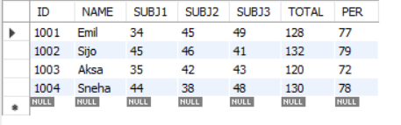select * from student;

1. **AIM:**

Create a Trigger for student table that will update another table shows the name, total marks and percentage.

**PROCEDURE:**

use TRIGER;

CREATE TABLE MARKS(MARKID INT PRIMARY KEY AUTO_INCREMENT,NAME VARCHAR(20),TOTAL INT,PER INT);

CREATE TRIGGER MARK_TRIGGER AFTER INSERT ON STUDENT FOR EACH ROW INSERT INTO MARKS(NAME,TOTAL,per) VALUES(new.NAME,new.TOTAL,new.per);

INSERT INTO STUDENT(ID,NAME,SUBJ1,SUBJ2,subj3)values(1003,'Aksa',35,42,43),(1004,'Sneha',44,38,48);

SELECT *FROM MARKS;

